The White Top Folk Festival 1931-1939
William Stein
Dedicated to the memory of Annabel Morris Buchanan—real American—real Southerner—progressive Southern woman (and fellow Texan)

Between 1931 and 1939 the White Top Folk Festival took place on the mountain by that name which lies in Washington and Grayson counties.¹ The Festival drew widespread interest from practitioners and advocates of folk arts from all over the eastern United States and from as far away as Europe. It is best remembered for the 1933 visit by Eleanor Roosevelt. Although it did not survive after 1939, its importance should not be forgotten.
The Festival was critically examined by David E. Whisnant in All That is Native and Fine,² which he reprised in a paper read at the Virginia Highlands Festival in Abingdon in 1998 entitled “The White Top Festival: What We (Have Not) Learned.”³ But aside from a very brief mention (one paragraph) in John Herbert (Jack) Roper’s talk at the 70th annual meeting of the Historical Society of Washington County, "1936 to 2006" (April 6, 2006), it has not been given an article-length treatment in any local history aside from that contained in Doug Ogle’s Whitetop: The Great Meadow Mountain of Virginia (2011). Whisnant presents a very comprehensive summary for each of the Festival’s eight seasons and of the people involved. He also wrote an article about the Festival in the Encyclopedia of Southern Culture.⁴ but his is not the final word. Helen Matthews Lewis and Rich Kirby challenged some of Whisnant’s conclusions in “All That Is Native and Still Undefined: A Response to David Whisnant.”⁵
In Southern Music / American Music, Bill C. Malone and David Stricklin offer background on the evolution of mountain music, or “folk music,” in the South and the often contravening efforts of folk musicologists like Cecil Sharp and settlement school women like Olive Dame Campbell to preserve ancient musical traditions that they had discovered in the Southern mountains.⁶
These efforts led directly to the folk festivals that began to appear in the 1920’s and 30’s in the South. By 1931 when the first White Top Folk Festival took place there already were two similar festivals in existence. In 1928, Bascom Lamar Lunsford had organized a group of performers in Asheville, NC to perform traditional music and dance in what would become known as the Mountain Dance and Folk Festival. Inspired by Lunsford’s success in North Carolina, Jean Thomas formed the American Folk Song Festival to promote mountain music in Kentucky. The National Folk Festival, begun by Sarah Gertrude Knott in 1934, was held at various locations and, as the name suggests, focused on folk music as it found expression in different parts of the country.⁷
The White Top Folk Festival grew out of a suggestion made by Ike Sturgill to Abingdon attorney John Blakemore that a fiddler’s contest be held on White Top on the 4th of July in 1931. In addition to being an attorney, Blakemore was a well-connected politician and a businessman. His company, White Top Company, owned the top of the mountain and had done some development there. Annabel Morris Buchanan, wife of Blakemore’s cousin John Buchanan, was President of the Federated Women’s Music Clubs of Virginia and Director of the Federation’s folk music section. A gifted musician in her own right, Mrs. Buchanan hosted a weekly Monday Afternoon Music Club in Marion, Virginia and in that capacity had become acquainted with John Powell, a southern classical musician of some distinction. He was also an advocate for the belief that mountain life, and especially the ballads that musicologists like Cecil Sharp and others had “discovered” in Appalachia a decade earlier, represented the last bastion of Anglo-Saxon purity in a rapidly expanding, increasingly urbanized, and ethnically diverse America.⁸ Transplanted Virginian Annabel Morris Buchanan, Virginia composer and proponent of the Anglo-Saxon folk-song school John Powell and local entrepreneur John Blakemore; from this star-crossed trio emerged the idea for the White Top Folk Festival.
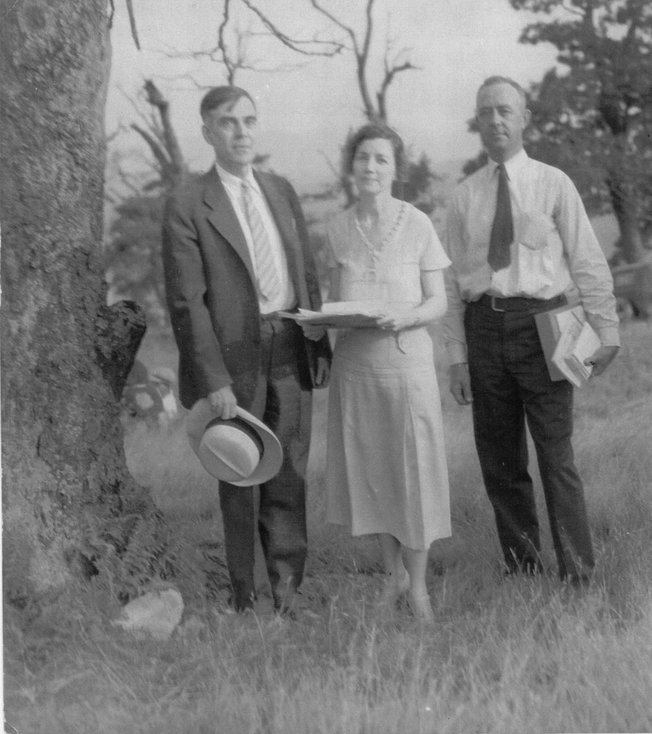
John Powell, Annabel Morris Buchanan, and John Blakemore

The progenitor of the White Top Folk Festival was the first Virginia Choral Festival in Charlottesville, VA in 1928 which was organized by Annabel Morris Buchanan and John Powell and which also included folk music.⁹ A number of notable performers from Southwest Virginia appeared there including Horton Barker, Jack Reedy, C.B. Wohlford and Ed and Frank Blevins. These artists formed the core of performers who appeared at White Top throughout the 30’s. The festival organizers were influenced by the mountain settlement schools which sought not only to educate Appalachian children, but also to discover and preserve mountain culture. David Whisnant, however, wrote that though these efforts were well-intended and did create an awareness and appreciation of the local culture, all too often, settlement school workers focused on elements of the local folk culture that reinforced their belief that the music and dance of the southern mountains were cultural artifacts which had been preserved since the days they were transported here from England, thereby ignoring any manifestations of culture that the local population might have contributed on their own. "[T]he professed...veneration of the settlement women for local culture was selective, and the mechanism of selectivity was the colored lens of their own culture, which was for all practical purposes the genteel popular culture of the turn of the century.¹⁰ As Helen Mathews Lewis and Rick Kirby observe, "In Whisnant's view the efforts of these women... represented a serious and destructive manipulation of mountain culture."¹¹
In the case of the White Top Folk Festival it appears that the shoe was on the other foot. Whisnant is fulsome in his praise for White Top Folk Festival organizer Annabel Morris Buchanan who had demonstrated an egalitarian appreciation for the folk idiom as early as 1923. It was through Mrs. Buchanan’s unstinting efforts that the Festival succeeded to the degree that it did. It was she, for example, who reached out to Eleanor Roosevelt in 1932, leading to the First Lady’s visit the following year. It was Annabel Buchanan likewise who sensed even in the flush of the success of the 1933 Festival that it was heading in the wrong direction. “[For] two cents I’d throw up the whole thing,” she wrote her collaborator John Powell. “I believe we are doing more harm than good.”¹²
Whisnant’s criticism is aimed principally at three men. First and foremost he is critical of John Powell, a talented composer who began his career with a genuine interest in preserving folk traditions. Whisnant comments that “His suite for piano In the South (begun about 1906) employed ragtime elements in one movement, Negro melodies in another and the fiddle tune “Arkansas Traveler” in its final movement….”¹³ Unfortunately, Powell’s later quest to preserve cultural “purity" resulted in a far less inclusive venue at White Top. While the rigorous selection process of musicians, with emphasis on music and dance with roots in the Anglo-Saxon tradition, led to early success, culminating in Eleanor Roosevelt's visit in 1933 when crowds in excess of 10,000 crowded onto White Top mountain, in later years the novelty wore off as festival organizers came to rely on the core group of the most popular musicians like Sailor Dad Hunt and C. B. Wohlford, and introduced folk elements like sword- and morris-dancing that had no cultural antecedents in the southern mountains but were popular with academics and elites. Crowds (and ticket revenue) fell, even as academic interest grew. The other males singled out by Whisnant for criticism are Richard Chase, a champion of sword dances and other folk dance traditions, who became the Festival’s Associate Director in 1936, and John Blakemore.
Blakemore and Mrs. Buchanan were at odds over the direction the Festival should take; Buchanan was passionately (one could argue fanatically) committed to the cultural aspects of the Festival, while Blakemore was principally interested in the commercial potential.¹⁴ As Chases’ star rose, Buchanan’s faded. There was no Festival in 1937 and the Festival planned for 1940 was rained out. After the 1936 Festival, Buchanan was no longer involved in the White Top Folk Festival. In 1938 and ’39 the Festival was managed by Blakemore, Powell, and Chase.
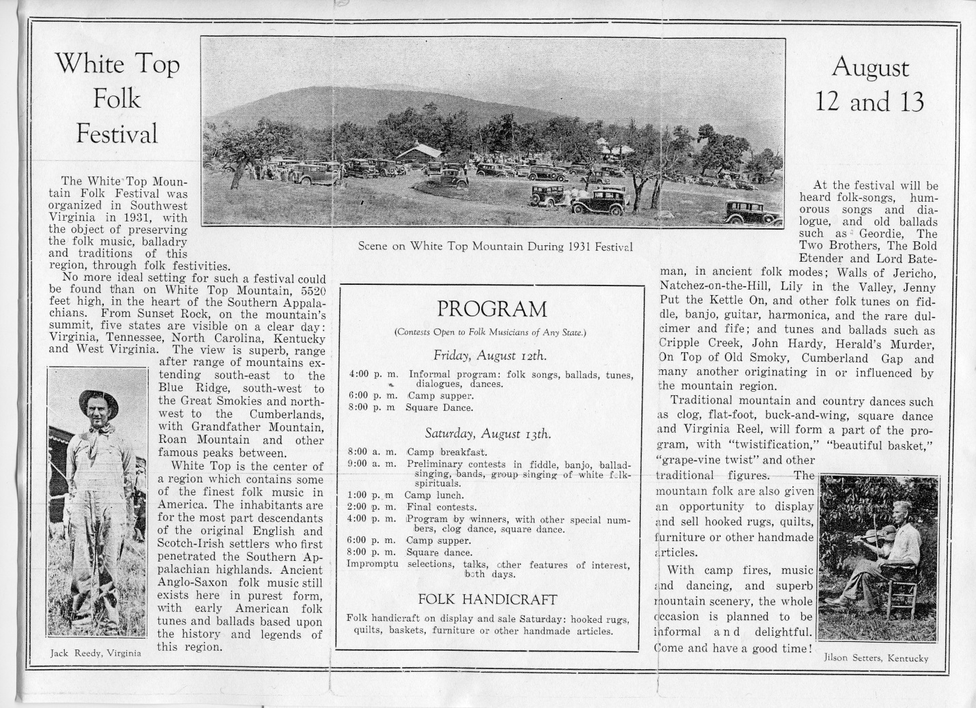
In "The White Top Festival: What We (Have Not) Learned," David Whisnant poses the question:
“What sorts of music were they [Powell and Buchanan] looking for?... [T]hey wanted old-time “folk” music of white mountaineers, and they emphatically did not want what they called the “tawdry” commercial hillbilly or country music that could be heard on phonograph records or the radio. To get what they wanted, they knew they would have to exercise considerable control over the musicians. ‘We’d better designate types of songs to be sung,’ Mrs. Buchanan said. ‘If we don’t, they are just as likely to sing ‘When You and I Were Young, Maggie.’”¹⁵
White Top Folk Festival: Chronology
1931 The first Festival included competitions in which eight fiddlers, six banjo and guitar players, seven clog dancers, six string bands, four ballad singers, two harmonica players, and one or two dulcimer players took part. Judges for the performances were Lamar Stringfield Powell, Buchanan, George Pullen Jackson who was an expert on white spirituals from Vanderbilt University, and Arthur Knecht who was the director of the Cincinnati Symphony.¹⁶
1932 The Festival this year included include seventy-five individuals and groups and lasted for two days (12-13 August). An estimated six thousand people were present on the second day.¹⁷
1933 This was the largest gathering for the Festival with more than eight hundred musicians. The Abingdon Virginian estimated that on Saturday when Eleanor Roosevelt attended numbered 22,000. In addition to music, the event included mountain handicrafts such as hooked rugs, folk tales, and children’s singing games which were directed by American folklorist Richard Chase, the author of Jack Tales and Grandfather Tales, stories that had been handed down for generations in the Appalachian region.¹⁸
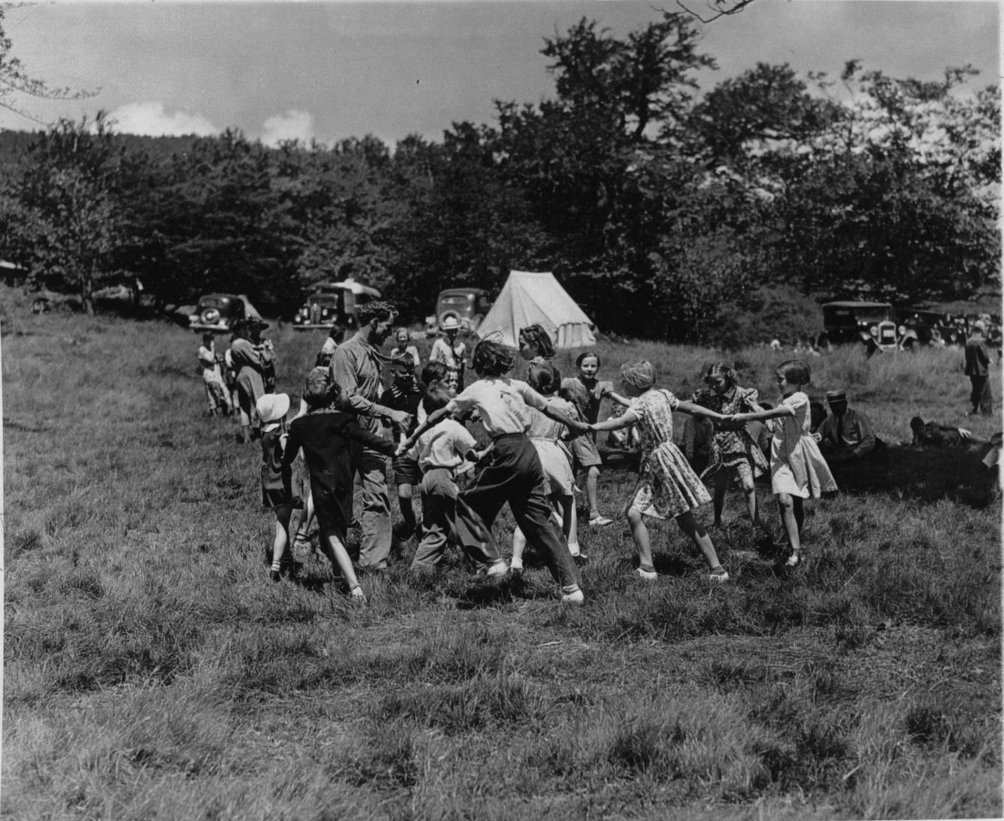
Richard Chase and dancing children at the 1938 WTFF (photo courtesy of David Winship)
1934 Despite heavy rains the fourth Festival took place 17-18 August at which time many of the regular performers participated such as S. F. Powell, sacred singers brought from Galax by W. E. Alderman Sailor Dad Hunt, Howard Wyatt a fiddler, C. B. Wohlford, (banjo player), Harve Sheets (clog dancer), and Horton Barker (ballad singer). Instead of the four ballad singers in 1931, twenty-two were reported to have performed in 1934. All or part of the Festival was broadcast by Richmond radio station WRVA. ¹⁹
1935 That year, sword dancing by boys from the Pine Mountain Settlement was introduced. In addition, the Barter Theatre performed Lula Volmer’s play “The Hill Between” which takes place in the southern mountains. Also, John and Alan Lomax made recordings of the Festival performances for the Library of Congress which are now in the American Folklife Center.²⁰
1936 Before the Festival took place in 1936, the White Top Conference was held at Marion College. Participants included Captain and Mrs. Kettlewell of the English Folk Dance and Song Society, Carleton Smith of the New York Public Library’s Music Division, Frank C. Brown, folk song collector and organizer of the North Carolina Folklore Society, and Robert Winslow Gordon, formerly Director of the Library of Congress’s American Folklife Center. Regardless of the national and international interest, the crowds were smaller, about three thousand on Friday and five thousand on Saturday. Yet, more than two hundred people competed and the Festival made a small profit.²¹
Charles Seeger, musicologist, composer, and father of folk singing legend Pete Singer attended that year. He observed that the “holy folk” who saw themselves as the preservers of the national culture, strictly screened those who sought to take part. "Altogether a feast of paradox.... [Such] preposterous self-sufficiency I have never seen at other festivals....²²
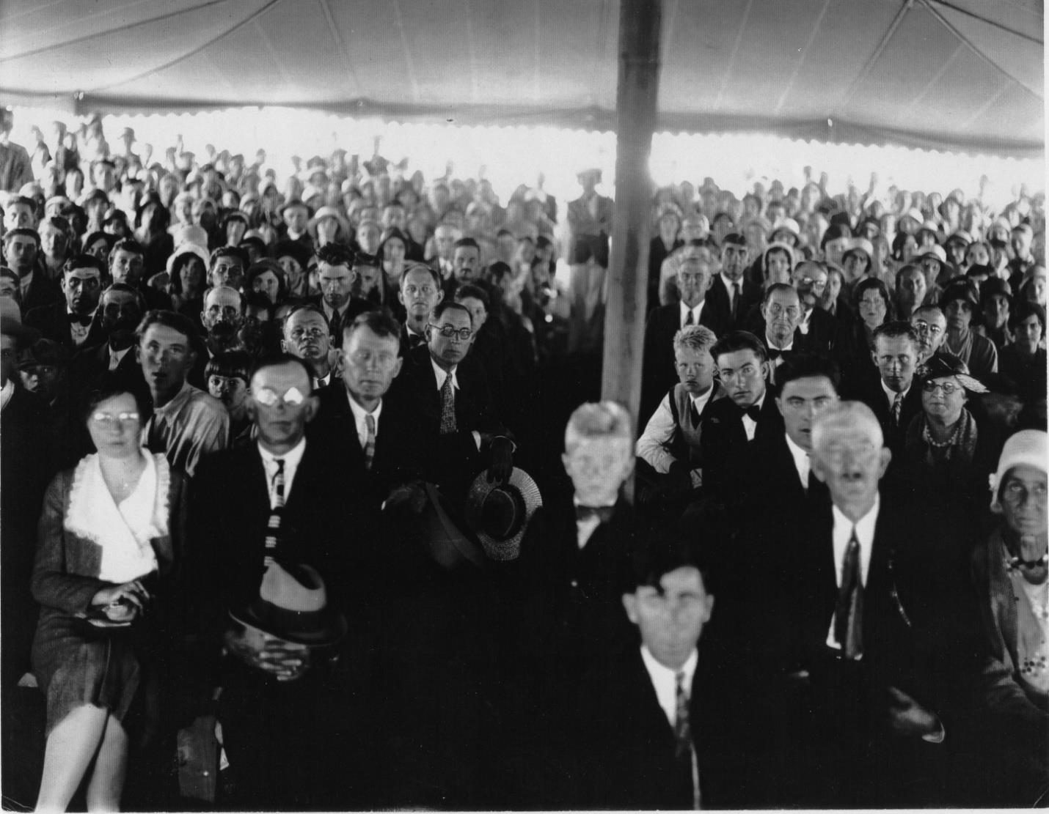
“Holy folk” settin’ [there]? Not a bit of it. The holy folk are standing outside the ropes while a handful of city folk sit…” Charles Seeger (photo courtesy of David Winship)

1937 There was no Festival.
1938 When the Festival took place again in 1938, about three thousand people attended and listened to a number of performers who had become regulars by that time. Although the Festival had been founded to showcase music and dance of the region, the Anglo-Saxon traditional concept of culture of Richard Chase, which dated back to an earlier age, increasingly dominated. This involved Punch and Judy shows, children’s games, a play by Barter Theatre, and a “special program” that was directed by Powell.²³
The Festival was broadcast on WRVA in Richmond and a recording of this can be accessed at “Appalachian Life and Culture: White Top Folk Festival.” Performers who can be heard on the recording include: F. A. Church of Konnarock, singing Katie Moore, Clyde Sturgill with the plaintive ballad of Sweet Jane, Council Cruise singing Locks and Bolts, Emory Stroop with The Twin Sisters and the incomparable Horton Barker with The Farmer’s Cursed Wife and The Miller’s Will. ²⁴
1939 Folk musicians from nine states assembled for the festival opening on August 11. The World Wide Photos rotogravure division of the New York Times sent a photographer to cover the festival...recognition that the event had become national news.²⁵
1940 Although plans were made for another Festival, heavy rains in the area caused considerable flooding with roads and bridges washed out with the result that the event was cancelled the day before it was to begin. Despite that a few people gathered on White Top, but no festivals took place after 1939.²⁶
Afterword
In 1961 Ulrich Troubetzkoy wrote, “White Top has no music anymore except the wind through the spruce and the ravens crying. At its peak the U.S. Engineers installed aerial warning towers. Picnickers come for the incomparable view across the mountain ranges into five states and the rickety pavilion is still standing.” ²⁷ Now even the pavilion is gone, torn down by the Forest Service when the mountain became part of the Mount Rogers National Recreation Area.
The White Top Folk Festival has all but disappeared from living memory and outside of David Whisnant’s chapter long treatment, written accounts of the Festival are scarce. Whisnant’s critique of the Festival was part of a larger examination of the social and economic changes which were taking place in the southern mountains in the 1920's and 30's, focusing on the arts and crafts revival and music festivals in western North Carolina, southwestern Virginia, and eastern Kentucky. The book examines efforts by institutions, such as the Hindman Settlement School, the John C. Campbell Folk School, and the White Top Folk Festival to preserve mountain culture in these areas in the face of radical changes in the social fabric brought about primarily by the shift to a “modern” industrial economy. Elsewhere Whisnant theorizes that the response to these changes was proscriptive:
“Potential performers were rigorously screened and frequently coached to conform to an image of traditional culture in the precious vestiges of an ancient English [Anglo-Saxon] cultural heritage, needing protection from the corrupting influences of modernity, and valuable as both raw material for art-music composers and a potential basis for a distinctive American “national culture.”²⁸

Beginning with Charles Seeger, many critics have seized on the elitist cast of the White Top Folk Festival when compared to Bascom Lamar Lunsford's Mountain Dance and Folk Festival, also established in 1931, in Asheville, NC. Seeger’s vitriolic criticism in a letter written in 1936 to Adrian Dornbush, Director of the Resettlement Administration where he was employed, is quoted at length in All That is Native and Fine.²⁹ “Seeger called the affair 'reactionary to the core,' detecting in it a veneration for Anglo-Saxon culture, which, with its apparent indifference to actual mountain music and mountain people, was at bottom not musical at all, but social, the idol of a self-styled cultural aristocracy."³⁰ Folklorist Jane Becker noted how folk festivals like White Top in the 30’s sometimes attempted to “sanitize culture, weeding out the vulgar and the crude and presenting only those forms that upheld their middle-class standards of propriety and taste.”³¹ In 1940 Agnes Rothery, at that time a well-known author of travel books, described the musical landscape of The “New” Dominion. She describes how Negro folk idioms, including song and dance, had been first forgotten and then exploited in Virginia, singling out the White Top Folk Festival as an example, “where the Festival confines itself to the ballad and folk song of Great Britain preserved by the folk of Virginia.”³²
Clearly some of the folk were represented, but not all, in particular black folk, though there is some confusion about this. In an article about the 1933 Festival in New River Notes, Mack Sturgill describes those fortunate enough to meet with the First Lady, Eleanor Roosevelt, when she attended on August 12. According to Sturgill the list included “both white and Negro Civilian Conservation Corps volunteers from local camps.”³³ Other sources suggest that the Negro CCC volunteers requested an appearance at the Festival that year but were denied. David Whisnant, who had access to John Blakemore’s papers and interviewed him, related in All That is Native and Fine Blakemore’s assertion that “No Negro contestants were permitted, and there have never been any on the mountain.”³⁴ Writing in the Oxford American in 2009, Abingdon native Christa Smith Anderson relates the touching story of how John Smith, who had been Mrs. Roosevelt’s father’s valet when he lived in Abingdon, was allowed to meet the First Lady. Aside from Mrs. Roosevelt’s cooks, Mr. Smith was the only black person allowed to attend the festival that year.³⁵
Whatever its failings, the White Top Folk Festival remains a significant cultural event. It was significant that it happened at all with the Depression just getting underway. Economic conditions in the Southern Appalachians were as bad, or worse, than anyplace in the country to begin with, and they only got worse as the Depression deepened. The fact that winners in the different music categories could earn anywhere from $2.50 to $10.00 for a day’s work was quite an incentive in the middle of the Great Depression when many people lacked any income. It was significant, too, in that it achieved national and even international recognition. Finally, it offered local musicians a showcase for talents which, with the advent of radio and recording technology, were ripe for commercialization. A number of the more popular White Top performers had already established themselves through their recordings. Henry Whitter, Jack Reedy, and Frank and Ed Blevins had all recorded in the 1920’s. Whitter was a session player at the famous Bristol Sessions in 1927. Other performers like Horton Barker, J.M “Sailor Dad” Hunt, and Texas Gladden and her husband Hobart Smith were also showcased. Each of them went on to record for the Archive of Folk Song at the Library of Congress. While exposure to a wider audience was a salubrious consequence of the festival for some of the musicians, it should be noted that commercial success for the musicians was far from the objective John Powell was seeking. Powell considered the music to be a pure strain of American music, with roots in Old England. The taint of commercialization would have been anathema to his cultivated sensibilities. John Blakemore was looking for commercial success, but not for the musicians. He was hoping to cash in on the interest in not just the music, but in folk arts, with the establishment of a permanent (tax exempt) training center. As Whisnant observed in All That Is Native and Fine, “Clearly, the White Top performers were squeezed between Powell’s ‘duty to Virginia’ and Blakemore’s commercial development of the mountain.”³⁶ Differences over these conflicting impulses along with genuine concern for the musicians, who the other principals treated as means to an end, may have precipitated Annabel Morris Buchanan’s withdrawal from the management team.
Annabel Morris Buchanan, though her fervor for tradition was at times quixotic, stands firmly in the tradition of women such as Katherine Petit and May Stone (of the Hindman Settlement School), and Olive Dame Campbell (of the John C. Campbell Folk School) in recognizing and seeking to preserve a unique and valuable cultural heritage.
WTFF, Notes
Notes:
- The current spelling is Whitetop, but at that time it was two words and I will retain that spelling for consistency and to avoid confusion.
- Whisnant, David E. All that is native & fine : the politics of culture in an American region (Chapel Hill : University of North Carolina Press, 1983)
- http://faculty.buffalostate.edu/fishlm/articles/whitetop.htm
- “White Top Folk Festival,” Encyclopedia of Southern Culture” (Chapel Hill, N.C.: UNC Press, 1989), 1089
- Appalachia Inside Out, II (Knoxville: University of TN Press, 1995), 651-654
- Malone, Bill C. and David Stricklin, Southern Music / American Music (Lexington, KY: University of Lexington Press, c. 1979; revised and expanded, 2003), 31
- Williams, Michael Anne. “Festivals, Folk.” Encyclopedia of Appalachia, Rudy Abramson and Jean Haskell, eds. Knoxville, TN: University of Tennessee Press (c. 2006) p. 861
- Malone and Strickland, 35
- Cohen, Ronald. A History of Folk Music Festivals in the U.S.: Feasts of Musical Celebration (Lanham, Md.: Scarecrow Press, 2008), 10
- Whisnant, All That is Native and Fine…, 51
- Appalachia Inside Out, 652
- Whisnant, All That is Native and Fine, 197
- Ibid., 219
- Ibid., 211
- Whisnant, “The White Top Folk Festival: What We (Have Not) Learned,” 2-3
- Whisnant, All That is Native and Fine, 190
- Ibid., 191. Troubetzkoy, Ulrich, “Music on the Mountain,” Virginia Cavalcade 11 (Summer, 1961), 7
- “White Top To Be Fiddlers’ Mecca: Old time musicians prepare to enter contests—new features announced,” Abingdon Journal-Virginian (July 6,1933), 2,3,7
- Whisnant, “All That is Native and Fine, 197. Ferrum College has a portion of the broadcast (described as the “White Top Fiddler’s Convention”) on its Digital Library of Appalachia website: http://dla.acaweb.org/cdm/search/searchterm/Richmond/mode/all/page/2. John Blakemore is featured on the recording giving a mission statement and a brief history of the festival.
- Troubetzkoy, 8. Correspondence between the author and Todd Harvey, Curator of the Lomax Collections, American Folklife Center, Library of Congress.
- Whisnant, All That is Native and Fine, 204
- Ibid., 207
- Ibid., 208-209
- http://bit.ly/WT_33
- Troubetzkoy, 10
- Ibid., 10
- Ibid., 10
- Encyclopedia of Southern Culture, 1089
- Whisnant, All That is Native and Fine, 206-207
- Cantwell, “Feasts of Unnaming,” http://xroads.virginia.edu/~drbr/cantwell.html (accessed 11/18/2015)
- Becker, Jane, Selling Tradition: Appalachia and the Construction of an American Folk, 1930-1940, (Chapel Hill: University of NC Press, 1998), 37
- Rothery,Agnes, Virginia, The New Dominion (New York, London: D. Appleton-Century Co. 1940), 228
- Sturgill, “First Lady Visits White Top,” http://www.newrivernotes.com/grayson_history_1933_whitetop_1stlady.htm (accessed 11/18/2015)
- Whisnant, All That is Native and Fine, 244
- Anderson, Christa Smith. “A First Lady in a False Kingdom: a curious convergence on White Top Mountain.” Oxford-American 67 (Winter 2009), 190
- Whisnant, All That is Native and Fine, 214
Works Cited
Anderson, Christa Smith. “A First Lady in a False Kingdom: a curious convergence on White Top Mountain.” Oxford-American 67 (Winter 2009)
Becker, Jane. Selling Tradition: Appalachia and the Construction of an American Folk, 1930-1940. Chapel Hill: University of NC Press, 1998: 37
Cantwell, Robert. “Feasts of Unnaming: folk festivals and the representation of folklife,” Online. http://xroads.virginia.edu/~drbr/cantwell.html (accessed: 08/24/2015).
Cohen, Ronald. A History of Folk Music Festivals in the U.S.: Feasts of Musical Celebration. American Folk Music and Musicians Series (Book 11). Lanham, Md.: Scarecrow Press, 2008.
Crawford, Bruce. “Folk Music at White Top,” New Republic, 76 no. 978 (30 Aug., 1933): 74-75.
Lewis, Helen Matthews and Rich Kirby. “All That is Native and Still Undefined: a response to David Whisnant.” In Appalachia Inside Out / editors, Robert J. Higgs, Ambrose N. Manning, Jim Wayne Miller ; associate editors, Laura L. Higgs ... [et al.], v. 2, Culture and Custom. Knoxville : University of Tennessee Press, c1995
Malone, Bill C. and David Stricklin, Southern Music / American Music. Lexington, KY: University of Lexington Press, c. 1979; revised and expanded, 2003.
Bill C. Malone. “Music.” In High Mountains Rising: Appalachia in time and place, edited by Richard A. Straw and H. Tyler Blethen. Urbana : University of Illinois Press, c2004.
“Real Southerner and the White Top Folk Festival,” The Southern Literary Messenger, 1 No. 6 (June, 1939): 404-406
Rothery,Agnes. “Music in the Air.” In Virginia, The New Dominion. New York, London: D. Appleton-Century Co., 1940.
Sturgill, Mark. “First Lady Visits White Top.” New River Notes. Online. http://www.newrivernotes.com/grayson_history_1933_whitetop_1stlady.htm. Accessed: 6/16/2015.

Troubetzkoy, Ulrich. “Music on the Mountain.” Virginia Cavalcade, 11, No. 1 (Summer, 1961): 4-11.

Whisnant, David E. All that is native & fine : the politics of culture in an American region. Chapel Hill : University of North Carolina Press, c1983
___“The White Top Festival: What We (Have Not) Learned.” Presented at the Virginia Highlands Festival, Southwest Virginia Higher Education Center, August 6, 1998. Online http://faculty.buffalostate.edu/fishlm/articles/whitetop.htm. Accessed 07/24/2014.
___“White Top Folk Festival.” Encyclopedia of Southern Culture. Charles Reagan Wilson & William Ferris, coeditors ; Ann J. Abadie & Mary L. Hart, associate editors. Chapel Hill : University of North Carolina Press, c1989: 1089

“White Top To Be Fiddlers’ Mecca: Old time musicians prepare to enter contests—new features announced,” Abingdon Journal-Virginian, July 6,1933 (Reprinted in the Abingdon Virginian, August, 1998).
Williams, Michael Anne. “Festivals, Folk.” Encyclopedia of Appalachia, Rudy Abramson and Jean Haskell, eds. Knoxville, TN: University of Tennessee Press c. 2006: 861.
Acknowledgement
Thanks to James Hagy and Susan Brown for editorial assistance and to David Winship for sharing his personal notes and collection of White Top memorabilia.

